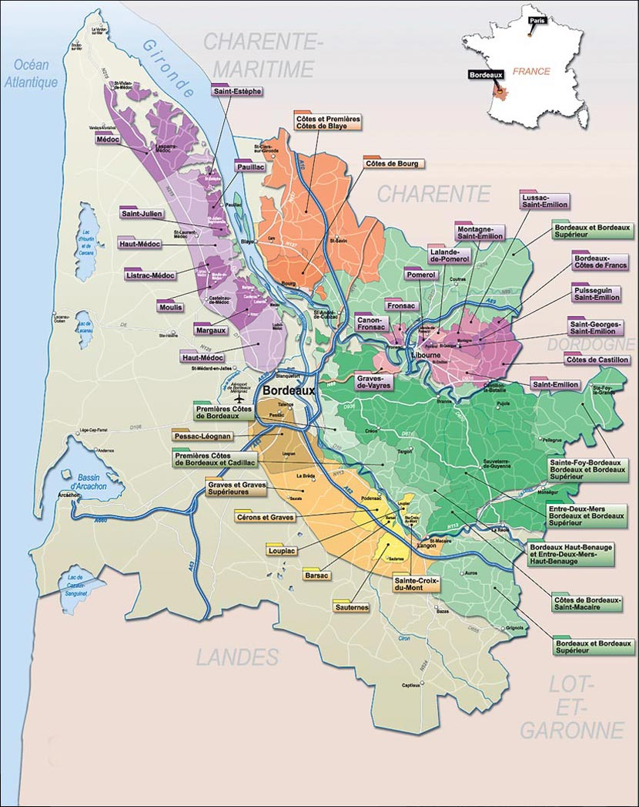

THE WINES OF BORDEAUX
Geography and Climate
- Bordeaux is located in the Southwest of France and covers 120,000 hectares (300,000 acres). It’s the largest fine wine district on earth. The region has 60 appellations within its borders
- The climate in Bordeaux is Maritime as it’s influenced by the Atlantic Ocean. The region is generally pretty temperate with short winters and often very warm summer’s. Humidity levels tend to be fairly high due to the proximity to the Atlantic and substantial summer rainfall.
Varietals
- Bordeaux produces a variety of wines –red, white, rose sweet and sparkling. Production is roughly 85% red, 13% white and 2% sweet wines.
- Red and Rose wines are produced from 6 permitted varietals – Cabernet Sauvignon, Merlot, Cabernet Franc, Petit Verdot, Malbec and Carmenere.
- White, sweet and sparkling are produced from 3 permitted varietals – Sauvignon Blanc, Semillon and Muscadelle
- Rarely do you ever see a mono varietal wine in Bordeaux (Pomerol is usually the exception, along with generic Bordeaux or Bordeaux Superieur), the wines get their character and profile from blending.
Major Regions
- The region is dissected into three major areas by the Gironde estuary and its 2 rivers the Dordogne and Garonne.
- The Left Bank – is regarded as the area that produces the finest wines of Bordeaux. This area is heavily dependent upon the Cabernet Sauvignon varietal that marries well with its sandy, gravel based soils.
- The Right Bank – know for Merlot and Cabernet Franc based wines, this area is home to small “garagiste” producers where the soils tend to be heavier and based on clay and sand.
- Entre Deux Mers – “between two seas”, this area sits in the center of the region between the Dordogne and Garonne. Known for fresh, vibrant white wines that offer tremendous value. Within this region are several sub-regions that produce both red and white wines, many representing great value -generic Bordeaux, Bordeaux Superieur, Graves de Vayres to name a few. This is the largest appellation and responsible for almost 75% of the Bordeaux sold.
- Medoc – Home to the most famous Chateaux and all 5 first growths. Within the Medoc you will find some of the most sought after and well know appellations
  - St-Estephe – the most structured and austere wines with plenty of acidity and ageing potential and flavors that tend towards earthy
  - Pauillac – Wines with body, structure and powerful tannins that are well to blossom with great secondary flavors and elegance. Home to Mouton-Rothschild, Lafite and Latour
  - Saint-Julien – Wines that exhibit finesse and harmony on the nose and palate, but with good structure and ageing potential
  - Margaux – These wines are known for their elegance, and their approachable fruit in their youth, but with structure and ageing potential. Home to Ch Margaux
  - Graves/Pessac-Leognan – Known for both great red and white wines. The red wines tend to be ripe with red fruits, smoke, minerality and finesse. The whites are aromatic with great roundness and depth, along with tremendous ageing potential
  - Sauternes/Barsac – the glorious sweet wines of Bordeaux produced from botrytized grapes that yield wines with rich, sweet wines flavored with apricot, peach and almond. The wines can be consumed young, but have the potential in great vintages to age for decades. The most famous wine from this area is Ch d’Yquem
  - St-Emilion – A beautiful historic village that produces wines based on Merlot and Cabernet Franc. The wines of the region tend to present themselves in various ways depending on the soil in which the grapes are grown, as well as the composition of varietals used in the blend. The wines have beautiful finesse and a generous nature with notes of tobacco and spice.
  - Pomerol – wines from Pomerol have a high percentage of Merlot in the blends. Some of the greatest wines of Pomerol (Petrus, Lafleur, Vieux Chateau Certan, Le Pin) come from vineyards grown on the plateau that has soils composed of blue clay. While the vineyards surrounding the plateau are more sand based resulting in lighter wines. The wines from Pomerol are exotic in nature with deep richness of dark berry and an underlying meatiness. Some of the most expensive and limited wines are produced here
  - Lalande-de-Pomerol – a sub-appellation to the north of Pomerol, Lalande-dePomerol is an area that can offer great value and wines liken to their more prestigious neighbor. The wines tend to have less density and richness, but still maintain lovely texture and balance
  - Other satellite regions of note – Fronsac, Canon-Fronsac, Montagne-Saint-Emilion, Cotes-de-Bourg, Cotes-de-Blaye

POLANER BORDEAUX PRODUCERS
Chateau Fantin - A refuge for monks in the 16th century, Château Fantin has been in the Houbaer family since 1890. Jean-Michel Chatelier, the current owner, is the great grandson on the maternal side of the family. A gem of baroque architecture, the house was restored in 1930 and is currently the home of Mr and Mrs Jean Chatelier. On the steep slopes overlooking the Dordogne River, the vineyard of Château Fantin faces south-south-east, towards the medieval town of Saint-Emilion. The slopes and soil composition (clay-limestone with a rocky subsoil) mean that drainage is good and the soil is not compact. A good, sunny exposure and the beneficial influence of the Dordogne River ensure that the vines grow and grapes ripen evenly.
- Ch Fantin Bordeaux Blanc 2010
  - Blend of Sauvignon Blanc, Semillon and Muscadelle
  - The grapes are hand harvested and gently pressed at low pressure
  - The must is allowed to settled and then fermented in stainless steel at low temperatures in order to preserve freshness and flavors
  - The wines is aged on its lees in tank until bottling in early spring
  - Crisp and racy with citrus peel, tart green apple and herbaceous notes
- Ch Fantin Bordeaux Rose 2010
  - A blend of 70% Merlot, 15% Cabernet Sauvignon and 15% Cabernet Franc
  - The grapes are hand harvested, crushed and macerated for a short period to allow for color and flavor development
  - The must is fermented at low temperatures in stainless steel in order to preserve freshness and flavors
  - Aged in tank and bottled in early spring
  - A deep rose with flavors of blood orange, stone fruits, strawberries and a hint of structure.
- Ch Fantin Bordeaux Superieur Rouge 2008
  - A blend of 90% Merlot and 10% Cabernet Franc
  - The grapes are hand harvested
  - Fermentation takes place in small, stainless steel vats so the mixing of aromas and skins is at a maximum when juice is pumped over
  - The wine ages in tank in a cool cellar for 18 months before being bottled.
  - The wine is fresh and fruity with spice and dark stone fruit flavors and soft integrated tannins

Chateau Sainte-Marie - Set right in the heart of the Entre-Deux-Mers region, this magnificent estate enjoys an excellent geographical position. The south-facing vineyard stretches over two very sunny hilltops which are among the highest points in the Gironde region. Gilles Dupuch and his family run their family estate since 1956 as a sideline business to his insurance brokerage. Because of his duel vocations, he has not fallen into the trap which many of their wine-producer neighbors have: rapid expansion, over- mechanization, and young vines sparsely planted. In fact, there are still a dozen heads of cattle on the property (which could be planted in AOC grapes). Since 1997, Gilles' son Stephane has been gradually taking over the property. He now is completely in charge and is in the process of transitioning the viticulture over to organic and biodynamic farming. The Chateau is certified organic as of the 2010 vintage.
- Ch Sainte-Marie Entre-Deeux-Mers Vieilles Vignes 2010
  - A blend of 63% Sauvignon Blanc, 27% Semillon and 10% Muscadelle
  - The vines average 30 years old and are densely planted at 5000-6000 plants per hectare in argilo-calcaire soils
  - The grapes are left in contact with the skins (maceration pelliculaire) for a brief period to give depth and then fermented in stainless steel
  - The wine is aged in tank on its lees for 6 months and stirred
  - Clean and packed with flavors of citrus oil, tangerine and white fruits. The finish is layered and fresh with nice persistence
- Ch Sainte-Marie Bordeaux Superieur Vieilles Vignes 2008
  - A blend of 72% Merlot and 28% Cabernet Sauvignon
  - The grapes were hand harvested from 35+ year old vines in late September and early October
  - The grapes are macerated for 3-5 weeks in tank to extract color, flavor and supple tannins and then fermented
  - The finished wine is aged in barrique (20% new) for 12 months
  - The wine has pretty texture and flavors of dark cherry, blackberry, spice and minerals with well rounded tannin and balancing acidity
Chateau Cantelaudette – Owned by the Chatelier family, this Chateau is located in the AOC of Graves de Vayres. The estate was developed by Jean-Julien Chatelier in 1870 and was planted with a diversity of crops, and manufactured clay and tiles from the quarry on the grounds. The property is set between the city of Bordeaux and Libourne on a plateau that overlooks the Dordogne River. The proximity to the river and the ocean offers a warm and moderating influence to help ensure ripe grapes.
- Ch Cantelaudette Rouge Cuvee Prestige, Graves de Vayres 2008
  - A blend of 70% Merlot, 20% Cabernet Sauvignon and 10% Cabernet Franc
  - After the grapes are harvested they are de-stemmed and crushed and allowed to macerate with daily pump overs
  - Fermentation and malolactic take place in tank at low temperatures to preserve freshness and fruitiness
  - The wine is racked and transferred to barriques (50% 1year, 50% 2year) to age for 12-18 moths until bottling
  - The richness of the Merlot adds a ripeness to the palate with flavors of stone fruit, licorice, spice and earth with freshness and supple tannic structure
Chateau La Reverence – Located behind the village of Saint-Emilion on a high plateau going to Pomerol, this small vineyard faces some very famous Grand Cru Chateaux. The estate is 3 hectares in size with vines planted to 60% Merlot and 40% Cabernet Franc.
- Chateau La Reverence Saint-Emilion Grand Cru 2007
  - A blend of 51% Merlot and 49% Cabernet Franc
  - The vines average 30 years in age and are planted in a combination of sandy topsoil/clay subsoil (50%), and highly concentrated clay topsoil and subsoil (50%)
  - The vines are left to grow in a natural habitat with minimal use of pesticides
  - Hand harvested and fermented using natural yeasts
  - The wine is fermented in 50% tank and 50% in 4 hectoliter barrels (gives the wine smooth tannin and complex aromas)
  - The wine is aged in barrique (about 1/3 new) for 12 months and bottled un-fined and un-filtered.
  - Deep, dark flavors of blackberry, cocoa, clove and underlying mineral notes
Chateau Tournefeuille - Château Tournefeuille is located in the village of Néac. Its vines cover 18 hectares forming one entity around the Chateau and fermenting room. What makes the estate special is the magnificent southwest slopes on which its vines are perched. Lit up by the sun in the afternoon and moderated by a meandering river that separates it from Pomerol, the grapes ripen beautifully. The vineyards are also adjacent to Latour à Pomerol, bordering both communes.
- Chateau Tournefeuille, Lalande de Pomerol 2007
  - The wines is made from a blend of 70% Merlot and 30% Cabernet Franc
  - The vines average 20 years old and are planted on a combination of 50%clay-gravel slope and 50% on the southerly exposed gravel slope. This steep hill dominates the valley of Barbanne
  - The vineyards are maintained with traditional practices and all harvesting is done by hand, with fermentation using natural yeasts
  - The grapes are de-stemmed and crushed into thermoregulated vats where they are left to macerate and ferment for 2-3 weeks
  - The wine is aged in barrique for 12-24 months, depending on the vintage, about 30-40% new
  - Floral notes compliment the dark cassis fruit, dark chocolate and spice notes. There’s a silky texture and firm tannins that completes a very pretty wine.
Chateau L’Ecuyer – Originally known as Chateau Bourgueneuf, its located not so far from the church of Pomerol next to prestigious Chateaux such as Clos L’Eglise and Chateua Clinet. The estate is comprised of 3 hectares planted in two plots, a portion which is planted on the famous plateau of Pomerol.
- Chateau L’Ecuyer, Pomerol 2007
  - Made from a blend of 90% Merlot and 10% Cabernet Franc
  - The vineyards are planted in two parcels. 1 hectare is planted on the prestigious plateau of Pomerol in gravely topsoil and deep clay subsoil. The other 2 hectares are planted just off the plateau in sandy topsoil with clay subsoil
  - Average age of the vines is 30 years old
  - The vines are tended using traditional methods and use of pesticides and chemicals is kept to a minimum
  - The grapes are de-stemmed and pressed directly to 4 hectoliter barrels to begin the pre-fermentation cold soak followed by a hot fermentation
  - The wine is aged for 12 months in barriques of which 50% are new, then bottled un-fined and un-filtered
  - The opulence of Pomerol is seen in this wine with its depth of plum, smoked meat and blackberry flavors and a rich texture, followed by minerality and soft tannins

