**Creating Tasting Sheets using Seven Fifty**

Log onto Seven Fifty - <http://www.sevenfifty.com/>

User name = Polaner email address

Password = first initial + last name + 6-digit b-day (ex. jsmith010180)

Select the **SAMPLES** tab.

Using the cross-hair, select a date for the Tasting Sheet

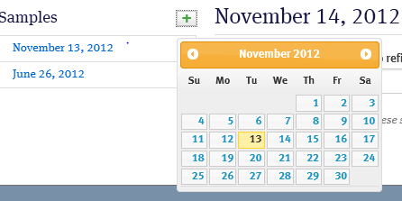

If you hover your mouse over the “Click here to enter a note…” you can add a note about the samples, (ex. Tasting with Janet Smith from Smith’s Wine Shop)

Click in the “Add a product…” field and either type the code or the item name or even varietal. A selection of wines will appear based on the criteria you wrote. Scroll down and select your item.

The item you selected will appear below the search function (this is the draft of the tasting sheet).

If you click in the space below the item, you can enter your own notes or click on “copy product description” which will pull from the item cards’ tasting notes.

Continue adding items until you have your list.

When finished, click on “Generate PDF” in the upper right corner. Save the PDF file to send or print for your tasting.

***TIP:*** *If you click the cog next to the "Generate PDF" button, you will be able to select "Hide Discounts above x bottles". If you select "0" bottles, you'll be able to hide all wholesale pricing. You can then use the note box on each product line to include the retail prices that consumers would see at a tasting.*

You can modify this as many times as you like for each tasting (adding and removing items). Just remember that it is date specific in Seven Fifty but the date doesn’t print on the PDF. Simply call up the date of your tasting sheet and change the “note about the samples” then generate the document.