**Cantina Filippi**

Filippo Filippi ↓

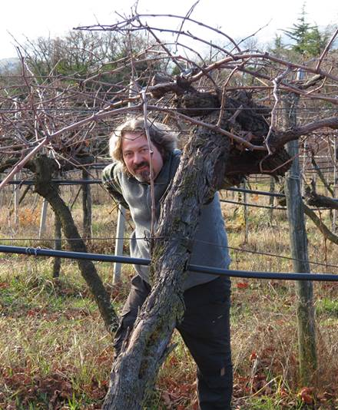

Filippi began bottling his own wine in 2003 but his family has been making wine since the Visco family bought the estate from the Conti Alberti. He began farming organically soon became certified organic in 2007. The soil in the vineyards is mostly rocky, volcanic clay with parts that are rich in limestone (particularly the Vigne della Bra). The property and vineyards are unique in that there is a rich biodiversity including wooded areas surrounding the vineyards. This is a critical aspect to the estate’s biodynamic practices and principles, as it allows for the vineyards to exist in harmony with the surrounding nature.  
  
This natural approach in the vineyards is carried forth in the cellar as well. The grapes are all hand-harvested and sorted. Fermentations occur with indigenous yeasts, in stainless steel tanks. The wines are held on their lees for an extended time, especially their top single vineyard wines. Their Soave vineyards are the highest in elevation for the appellation – ranging from 320-400 meters in elevation. All of the Soaves are 100% Garganega, of course, even though the appellation allows up to 30% of other varietals such as Trebbiano in the blends. FIlippi in fact does have some Trebbiano planted as well, but he reserves it for special cuvee called Turbiana (think Pepe Trebbiano, with a touch more “tang” from an underlying minerality).  
  
As for the Soaves, while most top examples are often rich and honeyed, Filippi’s wines are some of the most structured and mineral-driven. The high elevation and volcanic and limestone soils certainly come through in the brightness and focus of the wines. They often require time to open up, and can last for days with just a cork in the bottle. All of the wines certainly over-deliver for their price in terms of complexity and pedigree and all of them, the entry-level Castelcerino included, should improve with age (certainly 5-10 years).

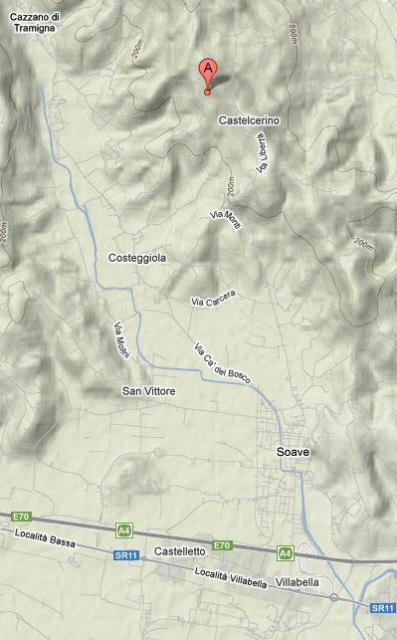

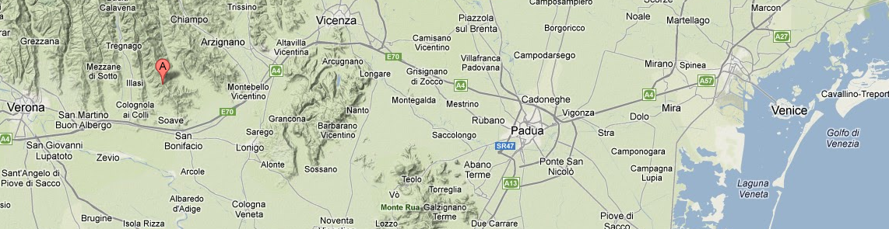Soave is located in the NE of Italy about 1 ½ hours from Venice, between Vicenza and Verona. Cantina Filippi is located about 10 minutes north of the town of Soave in the foothills of the Alps.



* **Soave Classico Castelcerino 2010 (12/750)**  IFI004 144, 128/3, 120/5
  + Vinified and aged in stainless steel.
  + Ten months on the lees in steel.
  + Forty-five year old vines.
  + Soil is clay and basalt rock.
* **Soave Colli Scaligeri Vigne della Bra 2009 (12/750)** IFI002 180, 172/2, 160/3
  + Vinified and aged in stainless steel.
  + Sixty year old vines.
  + Twenty months on the lees in stainless steel.
  + Soil is clay with basalt rock and limestone.
* **Trebbiano Turbiana 2008 (12/750)** IBI003 208, 196/2
  + Young vines.
  + This vineyards was planted with a strain of Trebbiano di Soave that the Filippi brothers found planted among the Garganega in the Vigne della Bra.
  + Six months on the lees in stainless steel.

