**Muscadet Sèvre et Maine**

* 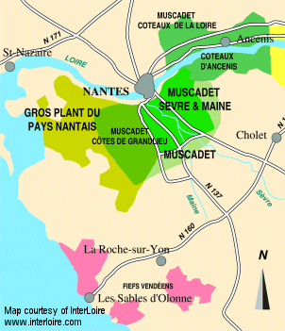The Loire reaches towards the Atlantic thru an increasingly flat and fertile landscape
* The region is dominated by maritime influences of the nearby Atlantic Ocean, resulting in cooler temperatures and more precipitation than the rest of the Loire Valley
* Deposits from the Nantes River have resulted in deep loams and clays of granite, and the winds have ground and weathered the original granites, gneisses, micas and schists into a very nutrient-rich soil
* There are four appellations with “Muscadet” in their title: Muscadet on its own, Muscadet Sèvre et Maine, Muscadet des Coteaux de la Loire, and Muscadet Côtes de Grandlieu
* At over 10,000 hectares (24,700 acres), Muscadet Sèvre et Maine is the biggest Muscadet appellation and one of the largest AOCs in France
* Melon and Gros Plant are the two grape varieties of the region. The words *sur lie* may be added to any appellation name provided the wines have been bottled directly off the fine lees

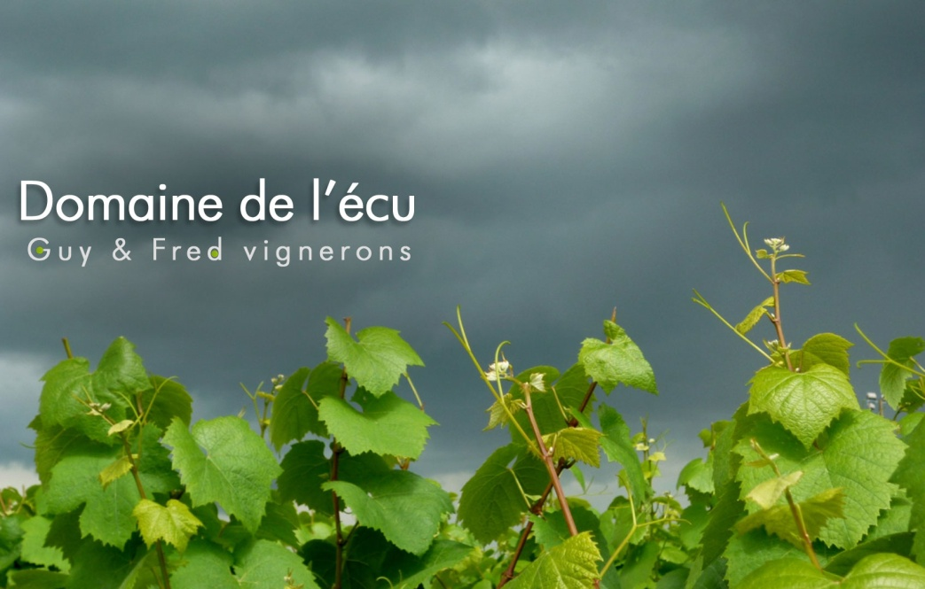

“*My future work is all in the vineyard: making old massal selections for vinestocks, looking after the health of the oldest vines, and above all trying to improve the quality of the roots. That work will never end.*” - Guy Bossard

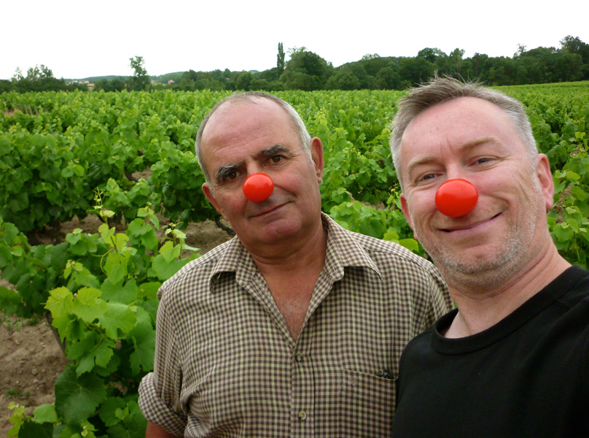Domaine de l’Écu is celebrated in France as a top-tier winery in Muscadet, but hasn’t yet developed the following or recognition it deserves in the US.  The estate was Bio before Bio was très cool.  They have has been certified organic for over 40 years and certified biodynamic for over 20 years. Unlike most regular Muscadet, the wines are aged *sur lie* for around 15 months, so the current 2010 vintage was just released. The estate produces three different “terroir” Muscadets, each crafted from different subsoils of the region; Gneiss, Orthogneiss and Granite. Longtime owner Guy Bossard is fanatic in the vineyards, crops extremely low, and produces Muscadets that have remarkable depth, precision, and ageability. Since he has no heirs, he recently sold the domaine to a passionate, dedicated enthusiast named Frederik Niger Van Herck who has asked Monsieur Bossard to stay on to manage the vineyards and consult in the cellar. Together they maintain the greatness of this pioneering estate.

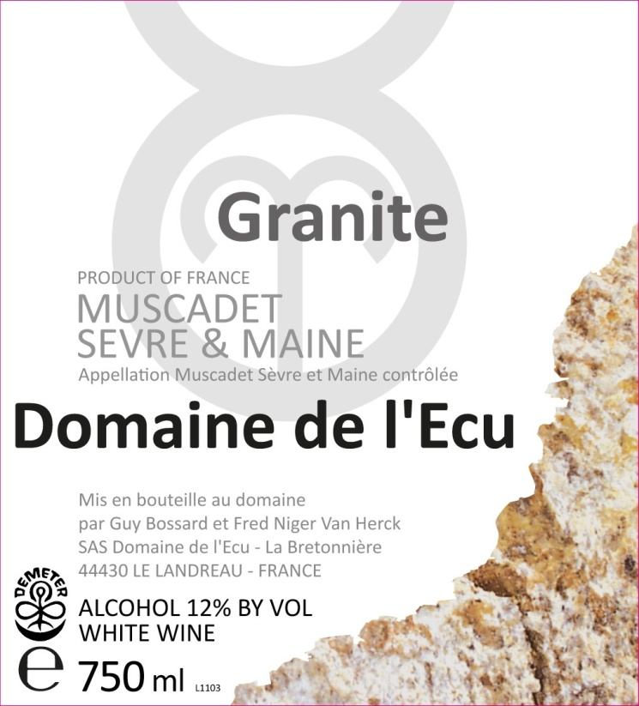

**The TERROIR Wines**

* 3 hectares parcel with 45-55 year old vines. Northwest slope
* Organically farmed since 1975. Biodynamic-demeter certified since 1996
* Light top soil. Sub-soil varies (gneiss, orthogneiss + granite)
* Soil worked manually and yields are kept low
* All grapes are hand harvested. Gravity fed with no use of pumps
* Wild yeast fermentations with no racking of the must
* Aged on the lees in underground vats

**Muscadet Sèvre et Maine “Gneiss” 2010 (12/750) $176, 168/2, 160/3**

* Gneiss is the first of the terroir wines to be harvested, and the earliest to express itself. The nose is opulent and rich in white fruits with notes of pear, citrus, hazelnut and aromas the sea. On the palate, the wine has a lively acidity and a minerally, saline finish

**Muscadet Sèvre et Maine “Orthogneiss” 2010 (12/750) $176, 168/2, 160/5**

**“Orthogneiss“ 2010 (6/1.5L) $196**

* Nose is subtle and elegant with the zest of citrus fruits, white flowers, spices such as ginger and cumin, and notes of flint, dried fruits and toasted almonds. The palate is sharp and focused, with great purity and elegance on the palate. Finishes with salty, chalky and slightly smokey notes. A wine with an excellent ability to age...

**Muscadet Sèvre et Maine “Granite” 2010 (12/750) $184, 176/2, 168/3**

**“Granite” 2010 (6/1.5L) $196**

* An elegant nose with pronounced notes of mineral, flint, silex, citrus fruits and oyster shells. The attack is sharp and precise; the palate is crystalline and pure, with salty, mineral notes, combined with chalk and citrus fruits. A transporting wine that promises to be long-lived

**Muscadet Sèvre et Maine “Taurus” 2010 (12/750) $360**

* Sourced from southwest –facing parcels of granite and orthogneiss
* Gravity fed with no use of pumps. Wild yeast fermentations with no racking of the must
* Aged on the lees for 10 months in underground vats, followed by 6 months in old barrels. An experiment and definite departure for the domaine
* 250 cases produced
* The name “Taurus” refers to the astrological sign of winemaker/co-owner, Fred

**Ludwig Hahn Brut NV (12/750)   $ 176, 168/2**

* 30% Folle Blanche (traditional grape variety from the Cognac region), 30% Chardonnay, 20% Melon de Bourgogne, 15% Cabernet, 5% Pinot Noir
* Plateau of clay-limestone. Subsoil of gneiss and orthogneiss
* Aged on the lees in underground vats
* Secondary Fermentation (prise de mousse) in the bottle with Champagne yeast
* The nose combines notes of minerals, dried grass, smoke, almonds, white fruits, apple and citrus. The palate is precise and lively, with a fine effervescence and great freshness

### **GEOLOGY ROCKS!**

### **Metamorphic rock -** Rock that was once one form of rock but has changed to another under the influence of heat, [pressure](http://dictionary.reference.com/browse/pressure), or some other agent without passing through a [liquid](http://dictionary.reference.com/browse/liquid) phase. Examples are marble, which can be formed from [limestone](http://dictionary.reference.com/browse/limestone), and slate, which is formed from [shale](http://dictionary.reference.com/browse/shale).

**Igneous rock** - Rock formed under conditions of intense heat or produced by the solidification of volcanic magma on or below the Earth's surface

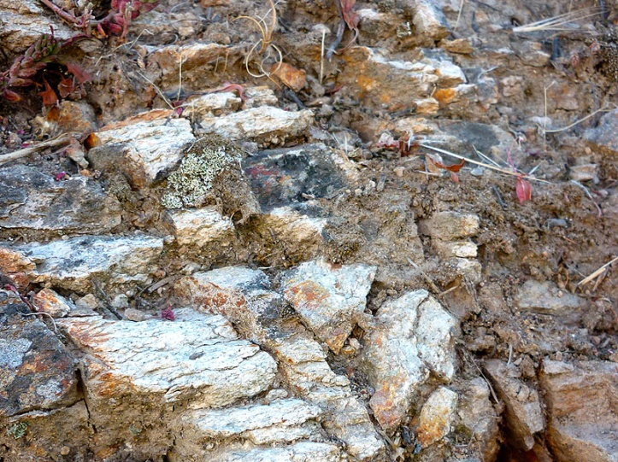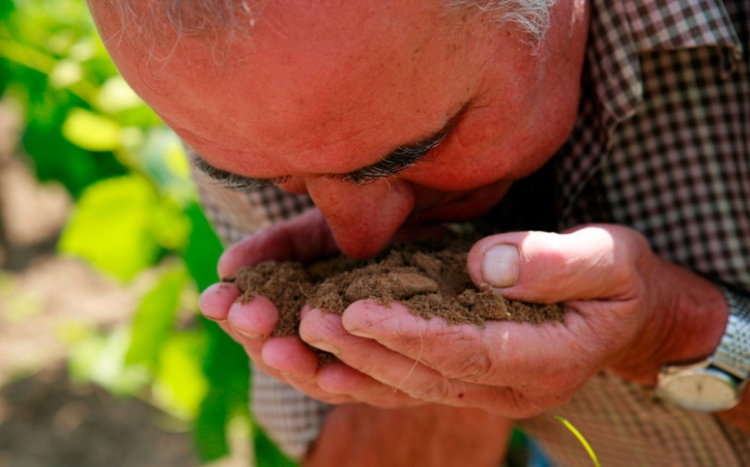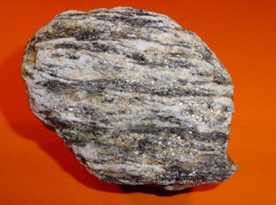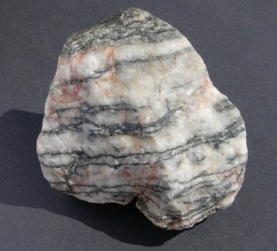

**PARAGNEISS**: gneiss derived from a sedimentary rock

**GRANITE**: a very hard igneous rock formation of visibly crystalline texture formed essentially of quartz and orthoclase or microcline.

**ORTHOGNEISS**: gneiss derived from an igneous rock

**GNEISS**: a [metamorphic rock](http://dictionary.reference.com/browse/metamorphic+rock), generally made up of bands that differ in color and composition, some bands being rich in feldspar and quartz, others rich in mica